In the Name of God
Familial Neurodevelopmental Disorder with Behavioral and Motor Abnormalities
Helix institute for Medical and Biological Science-
https://www. Helixinstitute.us/
Genomics Laboratory(Iran)-
https://www. Genomicslaboratory.ir/
writer: Zahra heidary

Abstract

Familial neurodevelopmental disorders with behavioral and motor abnormalities often exhibit complex inheritance patterns, particularly in consanguineous pedigrees. Hyperprolinemia type I (caused by biallelic PRODH variants) and calcium-channel-related disorders (involving CACNB4) have been implicated in overlapping neurological phenotypes, including intellectual disability, behavioral dysregulation, and gait/ataxia features.Whole-genome or exome sequencing data from a consanguineous Iranian family (first-cousin parents) with two affected adult daughters presenting non-educable intellectual disability, aggression, hyperactivity, restlessness, delayed walking, and gait imbalance were analyzed. Variant prioritization integrated zygosity, population frequency, gene–disease association (OMIM, ClinVar), inheritance model consistency, and phenotypic concordance. Segregation analysis remained incomplete. A homozygous PRODH variant classified as likely pathogenic was identified, consistent with autosomal recessive inheritance and parental consanguinity, supporting a potential diagnosis of hyperprolinemia type I. A heterozygous CACNB4 variant of uncertain significance was also prioritized due to strong phenotypic overlap with episodic ataxia and gait imbalance phenotypes previously linked to this gene. No definitive molecular diagnosis was established.

Clinical Features and Pedigree Description
The parents are consanguineous (first cousins: paternal uncle’s daughter and paternal uncle’s son) and have two affected daughters and five healthy daughters. The father has an affected brother who is deceased. This affected brother had three children: one affected son, one healthy son, and one healthy daughter.
The presence of consanguinity and affected individuals across multiple generations/branches of the family raises the likelihood of a Mendelian genetic disorder. An autosomal recessive inheritance pattern is a major working hypothesis; however, definitive determination of the mode of inheritance requires formal segregation analysis.
Clinical History and Phenotype
The patients are non-educable, aggressive, hyperactive, and restless, and exhibit delayed walking with gait imbalance. At the time of evaluation, the patients were 28 and 37 years of age, respectively. Head circumferences measured 57 cm (+2.42 SD) and 56 cm (+1.52 SD), respectively.
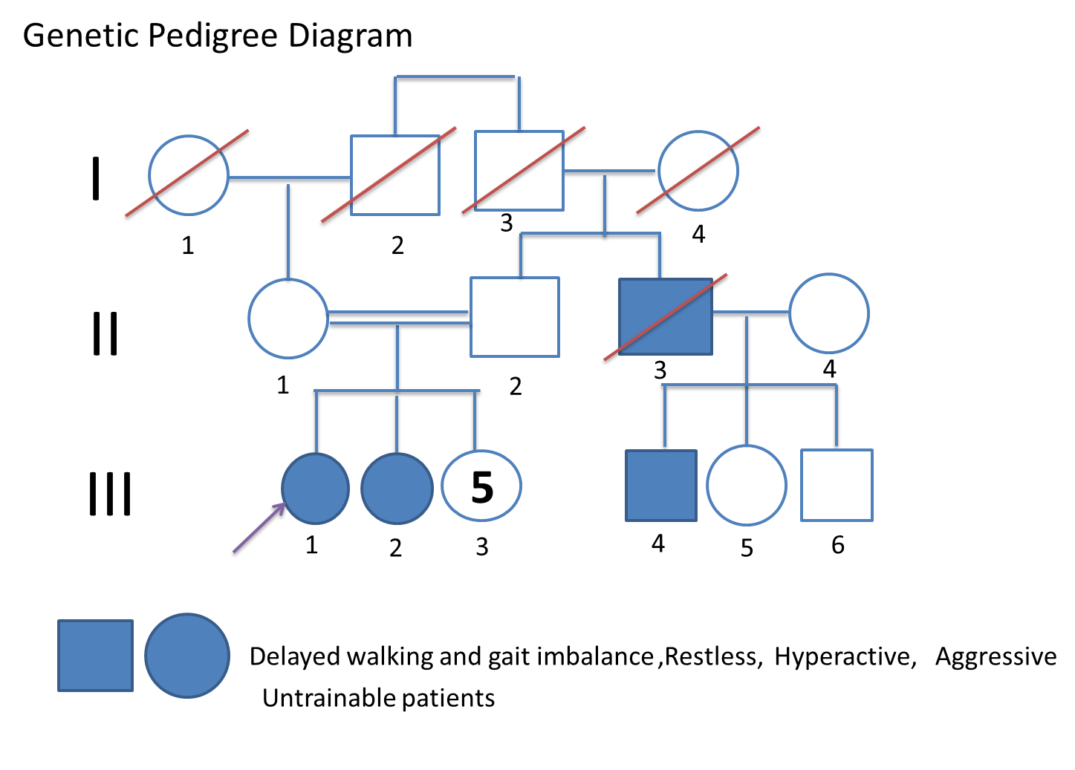

Genetic Analysis Methodology
Genetic investigation was performed using sequencing data. Candidate variants were prioritized according to gene–disease association, inheritance pattern, zygosity status, population frequency, and degree of gene–phenotype concordance. Useful information was obtained from databases including OMIM, ClinVar, NCBI, and the PubMed literature database.(3,4)

Genetic Findings
Gene | Zygosity | Variant Classification | Rationale for Selection
PRODH | Homozygous | Likely Pathogenic | Genotypic compatibility with autosomal recessive (AR) inheritance
CACNB4 | Heterozygous | Uncertain Significance | Phenotypic and neurological concordance

Interpretation of PRODH
Hyperprolinemia type I (HYRPRO1; MIM: 239500) is caused by mutations in the PRODH gene located at 22q11.2. Jaeken et al. (1996) described a patient with hyperprolinemia type I in whom FISH analysis demonstrated a submicroscopic deletion of the 22q11 region. This patient exhibited features of DiGeorge syndrome and also had deficiency of heparin cofactor II (MIM: 142360), a gene that also maps to 22q11. The parents and sister of the patient had normal proline and heparin cofactor II levels, and the 22q11 deletion was not detected in them. Jacquet et al. (2002) identified a homozygous PRODH mutation (L441P; 606810.0004) in two unrelated patients with severe type I hyperprolinemia accompanied by neurological manifestations, including seizures. One of these patients was additionally heterozygous for another PRODH mutation (R453C; 606810.0002).(1)
Afenjar et al. (2007) identified biallelic mutations or small deletions in the PRODH gene (e.g., 606810.0002; 606810.0004; 606810.0009) in four unrelated children with hyperprolinemia type I presenting a severe and homogeneous neurological phenotype, resulting in markedly reduced PRODH enzyme activity. One of these patients was a compound heterozygote for a 22q11 microdeletion and a point mutation.(2)
This gene is involved in proline metabolism. Biallelic PRODH disorders are associated with hyperprolinemia type I and follow an autosomal recessive inheritance pattern. Given the parental consanguinity and the identification of a homozygous variant in the affected individuals, the PRODH finding is genotypically consistent with an autosomal recessive model and was therefore regarded as an important candidate. Nonetheless, the pathogenicity of the variant must be evaluated independently of the established gene–disease association.(6)

Interpretation of CACNB4
The CACNB4 gene enables the activity of voltage-gated calcium channels that are involved in the regulation of presynaptic cytosolic calcium levels and plays a role in the regulation of synaptic vesicle exocytosis. It functions in several processes, including adult gait balance, cellular response to leukemia inhibitory factor, and development of hematopoietic or lymphoid organs. It is a component of the voltage-gated calcium channel complex, is active at glutamatergic synapses, and is expressed in the brain, heart, spinal cord, and urinary system. Human orthologs of this gene have been implicated in dilated cardiomyopathy, episodic ataxia, episodic ataxia type 5, and generalized epilepsy. The human ortholog is CACNB4 (voltage-dependent calcium channel auxiliary beta-4 subunit).(7)
Clinical evaluation of a French-Canadian family revealed recurrent attacks of vertigo and ataxia lasting several hours, accompanied by nystagmus, mild dysarthria, and truncal ataxia on interictal examination—findings that show strong phenotypic concordance with the gait and balance disturbances observed in the present patients.(9)
This gene encodes an auxiliary subunit of voltage-gated calcium channels and is involved in neuronal and cerebellar function. It is associated with certain neurological disorders, including ataxia-related phenotypes. Given the presence of balance impairment, gait disturbance, and severe neurodevelopmental problems in the affected individuals, CACNB4—through its role in neural function and motor disorders, particularly ataxia—may account for part of the observed phenotype. Because the observed variant is reported in the heterozygous state, its interpretation requires careful assessment of the variant type, the disease associated with that specific variant, and familial segregation analysis.(5)

Comparison of Candidate Genes
*PRODH: Stronger evidence from the genotypic perspective—homozygosity and compatibility with an autosomal recessive model.(8)
*CACNB4: Stronger evidence from the phenotypic perspective, particularly regarding balance and gait impairment.(9)
Accordingly, the two genes were prioritized as complementary candidates from two complementary perspectives.(8,9)

Study Limitations
Functional evidence for the variants is limited. Phenotypic concordance alone is insufficient to establish pathogenicity. According to the official ACMG/AMP guidelines, standardized criteria for variant interpretation apply:
*Incomplete segregation: Segregation evidence (criterion PP1) carries weight only when multiple family members are tested and complete co-segregation is demonstrated; absence of segregation data across all family members reduces the strength of the evidence.
*Absence of biochemical/functional data: Functional evidence (PS3) and biochemical data (e.g., plasma proline levels for PRODH) are essential for strengthening the evidence; their absence limits variant classification.
*Phenotypic concordance alone is insufficient: Criterion PP4 (phenotype match) provides only supporting-level evidence and is not, by itself, sufficient to establish pathogenicity; a combination of multiple lines of evidence is required.(10)

Conclusion
Based on the integration of pedigree, phenotypic, and genotypic data, the genes PRODH and CACNB4 were identified as prioritized candidates in this family. PRODH was primarily considered because of its homozygous state, consistency with an autosomal recessive model, and the presence of parental consanguinity, whereas CACNB4 was regarded as an important phenotypic candidate because of its functional and disease association with the nervous system, ataxia, and motor disorders—particularly in the context of the patients’ balance and gait impairment. Nevertheless, the present findings alone are insufficient to establish a definitive molecular cause of the disease. These two genes are presented as prioritized research candidates rather than as confirmed causative genes.(11)

References
1. Afenjar A, Moutard ML, Doummar D, Guet A, Rabier D, Vermersch AI, Mignot C, Burglen L, Heron D, Thioulouse E, de Villemeur TB, Campion D, Rodriguez D. Early neurological phenotype in 4 children with biallelic PRODH mutations. Brain Dev. 2007;29:547-552. PubMed: 17412540.
2. Baron M. Genetics of schizophrenia and the new millennium: progress and pitfalls. Am J Hum Genet. 2001;68:299-312. PubMed: 11170887.
3. https://www.ncbi.nlm.nih.gov/pmc/articles/PMC4544753/
4. https://pubmed.ncbi.nlm.nih.gov/25741868/
5. Escayg A, De Waard M, Lee DD, Bichet D, Wolf P, Mayer T, Johnston J, Baloh R, Sander T, Meisler MH. Coding and noncoding variation of the human calcium-channel β4-subunit gene CACNB4 in patients with idiopathic generalized epilepsy and episodic ataxia. Am J Hum Genet. 2000;66(5):1531-1539.
6. Jacquet H, Raux G, Thibaut F, et al. PRODH mutations and hyperprolinemia in a subset of schizophrenic patients. Hum Mol Genet. 2002;11(19):2243-2249.
7. Alliance of Genome Resources. Cacnb4 calcium channel, voltage-dependent, beta 4 subunit [Mus musculus]. Updated July 2025. Available from: https://www.alliancegenome.org/gene/MGI:103301
8. Jacquet H, Berthelot J, Bonnemains C, Simonneau M, Saugier-Veber P, Raux G, Frebourg T, Campion D. The severe form of type I hyperprolinaemia results from homozygous inactivation of the PRODH gene. J Med Genet. 2003;40(1):e7. doi:10.1136/jmg.40.1.e7. PMID: 12525555.
9. Escayg A, De Waard M, Lee DD, Bichet D, Wolf P, Mayer T, Johnston J, Baloh R, Sander T, Meisler MH. Coding and noncoding variation of the human calcium-channel β4-subunit gene CACNB4 in patients with idiopathic generalized epilepsy and episodic ataxia. Am J Hum Genet. 2000;66(5):1531-1539. doi:10.1086/302909. PMID: 10762541.
10. Richards S, Aziz N, Bale S, Bick D, Das S, Gastier-Foster J, et al. Standards and guidelines for the interpretation of sequence variants: a joint consensus recommendation of the American College of Medical Genetics and Genomics and the Association for Molecular Pathology. Genet Med. 2015;17(5):405-424. doi:10.1038/gim.2015.30. PMID: 25741868.
11. MacArthur DG, Manolio TA, Dimmock DP, Rehm HL, Shendure J, Abecasis GR, et al. Guidelines for investigating causality of sequence variants in human disease. Nature. 2014;508(7497):469-476. doi:10.1038/nature13127. PMID: 24759409.

